Endless Runner

An Endless Runner Video Game Design

Document by

Risav Bhaktaraj

## Game Overview

Concept: To design and produce an Endless Runner with Fog Mechanics to determine gameplay.

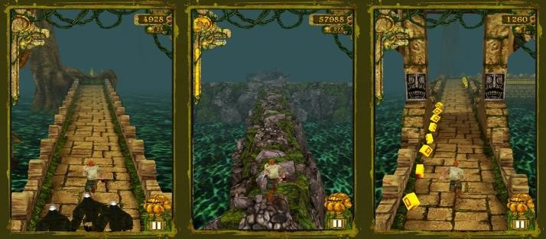

(Image credit: 2020.*Temple Run*. Google.)

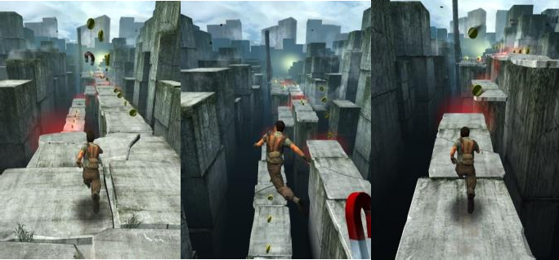

(Image credit 2014. *The Maze Runner*. pikpok.com.)

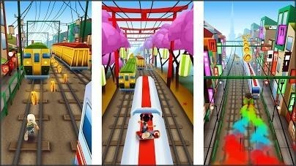

(Image credit: Fazl, 2013. *Subway Surfers)*

#### Genre

An Endless Runner Video game is a game characterised as an action game genre in which a player needs to run in a fixed path or pathways. The levels within an endless runner are usually linear and have no end so the main purpose of them is for a player to obtain a high score with each attempt at a level. (Jerry Momoda, JM. 2013)

Endless runners are generally easy to learn with basic controls (swipe left, right, up, down), though this is the case it is often hard to master these controls depending on how well the player is progressing in the game. E.g. If the player has been running in the game for a long enough period of time then their character will gradually run faster as they play, requiring a player to react faster to obstacles in the environment that could slow them down and reset their run or score multiplier if they collide with them.

#### A Brief History

The Endless Runner genre found its roots from 2D platformer games in the 90s. During this period, 2D platformers such as Super Mario were massive in popularity. The gameplay was basic, the player can control all aspects of the main character (Mario), including jumping, moving, and shooting.

With the production of tablets and smartphones since 2007, mobile consumption habits turned to short term attention spans. Users prefer ‘snackable gaming’ where game sessions are minutes rather than hours. Developers had to make 2D platformer games more basic to meet this demand.

The first set up involved copying the 2D platformer experience on the mobile device, with no movement controls. Developers ended up making the main character run without stopping. Players were provided only two controls – jump and shoot. The games were designed to be never ending. This was one of the earliest endless runners. Monster Dash is an excellent example of this. It is referred to as two touch endless runner (2TIER). (Ben Chong, BC. 2015)

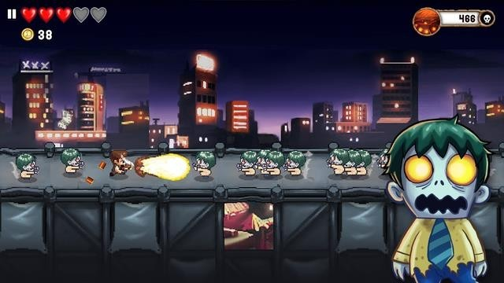 (Fig 1. Ben Chong, BC. 2015)

The second set up was made even more basic. The game only has one touch control, rather than two touches. This made sense as the mobile user is regularly on the go, holding their device on one hand. Developers started creating characters that could run and shoot automatically. The user just needed to tap their screen to jump.

This gave birth to an entire subset of one-touch endless runner (1TER) games, these include Jetpack Joyride (tap to make the jetpack boost) and Flappy Bird (tap to fly and ascend).

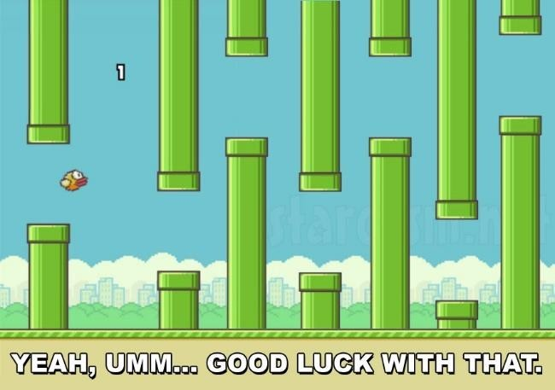

(Fig 2. Ben Chong, BC. 2015)

Runners developed by Imangi Studios carved a path for runners with the development of Temple Run, Temple Run 2, Temple Run Brave and Temple Run Oz. They collaborated with Disney to use the property of Brave and Oz films. Every game includes the four different swipe controls and even tilt controls. Brave added a “shoot” mechanic (archery). Temple Run slightly targets a mid-core, arcade style player.

Subway Surfers is an excellent example of a game to be produced in the genre, taking the best mechanics from Temple Run and introducing new mechanics such as a three-way lane system and three heights of elevation. E.g. Jumping on top off trains and sliding down a hill. The game is user friendly to new players with an adaptive difficulty system which only becomes more difficult depending on how much progress the player makes and how skilled they become as they play.

(Jerry Momoda, JM. 2013)

#### Jetpack Joyride

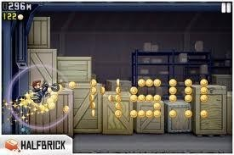

Endless runners have become popular because of side-scrolling mobile games such as Jetpack Joyride by Halfbrick Studios and Doodle Jump which is a vertical-scroller by Lima Sky. These are important to note as the change in perspective from side- view to behind-view has had a big impact on the change in game play.

Runner games sometimes have low retention due to early engagement and brief play times are quickly met with scaling difficulty and walls to progress. There are few things more demotivating for a player than when they finally understand just how to play an endless runner only for them to suddenly need to adapt to the increased difficulty through faster reactions and understanding of aids and barriers. Level progression is set up in a linear way and can become repetitive with little variety along the way. This was often used in early coin-operated arcade games where limits in storage made games shorter in length.

This can however depend on the target audience. Some audiences could see this as the opposite and find it more motivating to continue playing, such as the mid-core, arcade style player,

#### Target Audience

Often Runner games have high engagement as any progress made by the player requires deep focus to the action presented. They are enjoyed by players of all skill levels, but not many players have the skill to excel. (Jerry Momoda, JM 2013)

The game I am making targets a mid-core, arcade style player, this is because of the mechanics and how they are utilised within the game. The player must keep a level head and have good concentration skills to excel in this game. Obstacles will be encountered during each run and dangerous fog clouds will also be encountered, because of this the player will need to make effective use of the power ups and flashlight in the game to aid them.

The longer the player is running the bigger the score they will achieve, thus making the game also increase in difficulty by making the players character gradually run faster as they play. This will then in turn require the player to make logical decisions faster and to decide whether the power ups or collectibles they see are worth getting or avoiding.

#### Pedagogical objective(s)

The Player will be expected to learn and understand how to approach and deal with the various types of obstacles and fog clouds they encounter in the game. The fog cloud variations will be indicated by their colours and outlines:

Black fog will reduce the players vision making it difficult to progress. Red fog will damage the player’s health.

Blue fog will slow the player back down to their starting speed which will also result in the score slowly building up again.

The player can deal with obstacles by moving around or jumping over them.

The player can deal with fog clouds by moving around them or using the flashlight to dissipate them.

#### Look and Feel

I am targeting my games art style to replicate the art style used by temple run, as it is a relatively easy art style to follow, especially when working with low poly as- sets and low poly modular assets which I am using in my game.

I explored cell shading techniques to try and get my game to look more cartoony and similar to Temple run. I followed an Unity Youtube tutorial to help me further develop my environment

COMP305 – Game Programming

Assignment 1 Part2

Game Design Document

Endless Runner

An Endless Runner Video Game Design

Document by

Group Members

1.Risav Bhaktaraj –301313734

Tables of Content:

1.UI

Welcome to our sleek and intuitive menu screen UI designed specifically for Unity! Our menu interface boasts a clean and minimalist design, allowing for easy navigation and quick access to game options. With visually appealing buttons and icons, players can effortlessly browse through various sections, such as settings, controls, and game modes. The menu screen provides a seamless user experience, ensuring smooth transitions between screens and a responsive interface that keeps you engaged. Whether you're adjusting audio settings, selecting a new level, or checking your achievements, our Unity menu screen UI ensures that your gaming journey starts off on the right foot.

1.1 Start Screen

We created a simple start screen which has the title of the game a button to play the game and lastly a high score display.

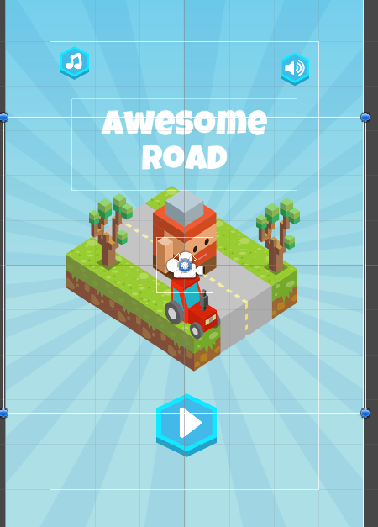

1.2 Death Menu

Introducing the captivating and immersive death menu in our thrilling platformer game! When you meet your demise in the game, our death menu interface takes center stage, offering a unique and engaging experience. The screen transitions into a dark and atmospheric environment, setting the tone for reflection and introspection. Visually striking graphics and animations create a sense of tension and anticipation, heightening the emotional impact of the gameplay. The death menu provides essential information such as the number of lives remaining, level progress, and an option to restart or continue from a checkpoint. With intuitive controls and clear visual cues, players can quickly navigate through the menu, making choices that affect their next move. Whether you choose to retry the level or strategize a different approach, the death menu in our platformer game adds an extra layer of depth and excitement to your gaming experience

2 Environment

Welcome to an exhilarating endless runner game where the environment is as dynamic and breathtaking as the action itself! As you sprint through the immersive world, you'll encounter a visually stunning environment that is teeming with life and filled with diverse landscapes. From dense forests to scorching deserts, each location is meticulously crafted with vibrant colors, intricate details, and impressive depth. As you dash forward, the scenery seamlessly changes, offering a sense of progression and excitement. Obstacles and challenges are seamlessly integrated into the environment, demanding quick reflexes and precise maneuvers to navigate through them

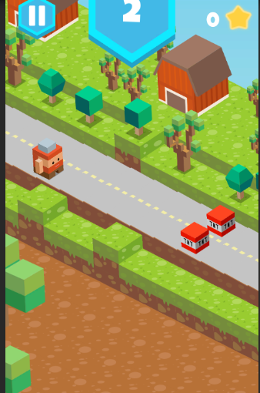

3.Player

Imagine stepping into the shoes of a fearless and agile player in our thrilling endless runner game. As the protagonist, you embody a determined and adventurous spirit, ready to conquer any obstacle that comes your way. Your character exudes a vibrant energy, with a sleek and athletic physique that reflects their exceptional agility and speed. Dressed in a stylish and functional outfit, your player stands out amidst the dynamic and visually stunning environments.

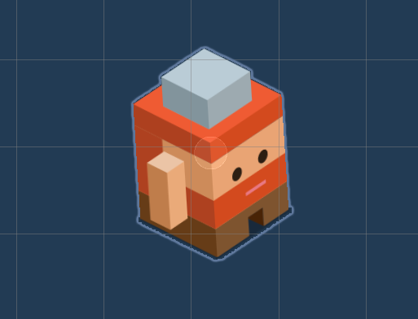

COMP305 – Game Programming

Assignment 1 Part3

Game Design Document

Endless Runner

An Endless Runner Video Game Design

Document by

Group Members

1.Risav Bhaktaraj –301313734

1. Character Movement:
   * The character should continuously move forward automatically at a constant speed.
   * Allow the player to control the character's actions, such as jumping, sliding, or moving between lanes.
   * Handle input from the player to trigger these actions and update the character's position accordingly.
   * 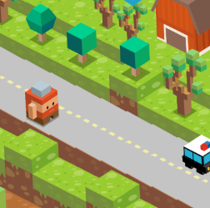
2. Obstacles:
   * Generate obstacles dynamically at regular intervals in the game world.
   * Obstacles can include various objects like crates, pits, barriers, or moving enemies.
   * Ensure that obstacles are randomized and appear in a way that poses a challenge to the player.
   * Remove obstacles that are no longer visible on the screen to free up memory.
   * 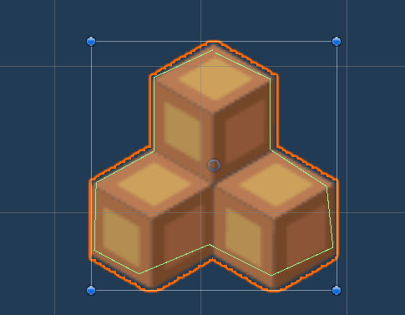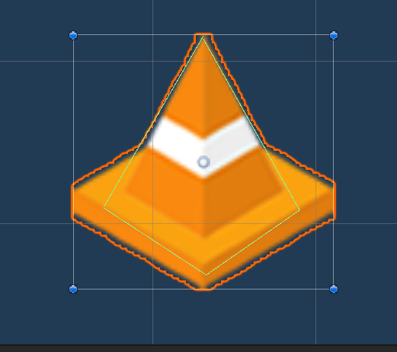
3. Collision Detection:
   * Continuously check for collisions between the character and the obstacles.
   * If a collision occurs, trigger an appropriate action, such as game over or reducing the character's health.
   * Determine collision boundaries accurately to ensure fair gameplay.
   * 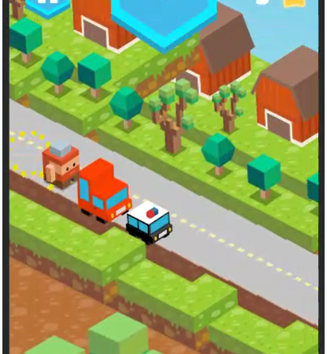
4. Scoring and Progression:
   * Keep track of the player's score, which increases over time or by collecting power-ups or coins.
   * Update the score display in real-time.
   * Gradually increase the game's difficulty as the player progresses, either by increasing the speed or introducing more challenging obstacles.
   * 
5. Game Over:
   * Determine the conditions for a game over, such as the character running out of health or falling off the screen.
   * Display a game over screen with the player's final score and any other relevant information.
   * Provide options to restart the game or return to the main menu.
   * 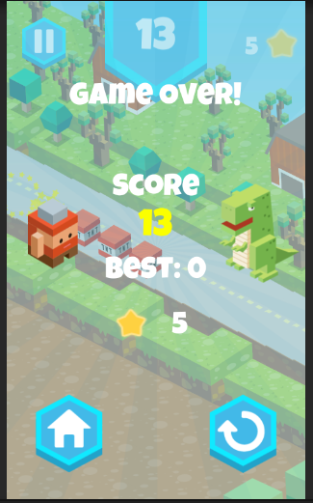
6. Menu and UI:
   * Implement a main menu to start the game and access additional features like settings or high scores.
   * Design a user interface that displays the current score, health, power-ups, and other relevant information.
   * 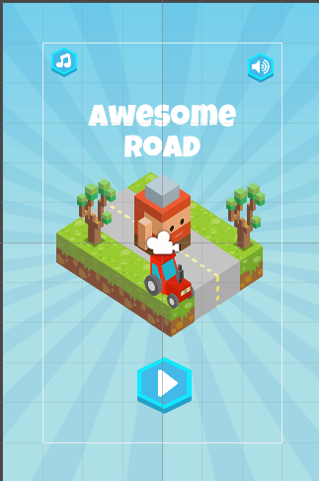
7. Sound and Visual Effects:
   * Add sound effects and background music to enhance the gameplay experience.
   * Include visual effects for actions like jumping, sliding, or collecting power-ups to make the game more engaging.

**Github link**

**https://github.com/Panicshoe/Game-Programming.git**